Animatronic skull build instructions

Parts:

The projects contains the following parts.

We recommend printing all parts in Brim, 100% scale, 20-30% infill and with Petg(PlA is also an option but you should use higher infill), keep in mind that you don’t want the parts the be too heavy since you’ll need stronger servos.

1\*B1: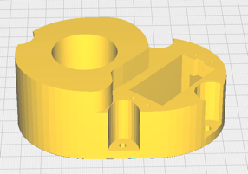 1\*N1: 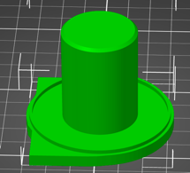 1\*N2: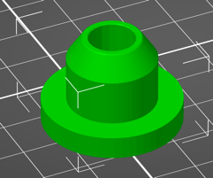

1\*N3: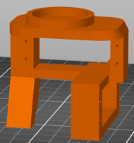 1\*N4: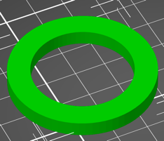 1\*N5: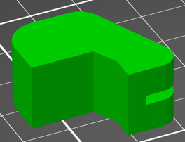

1\*F1: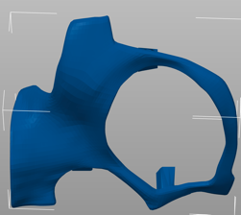 1\*F2: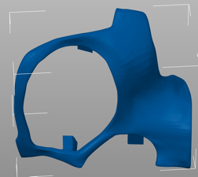 1\*F3: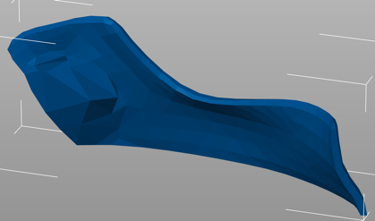

1\*F4: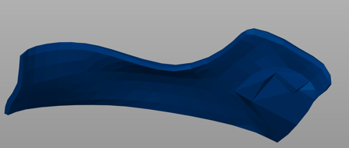 1\*J1: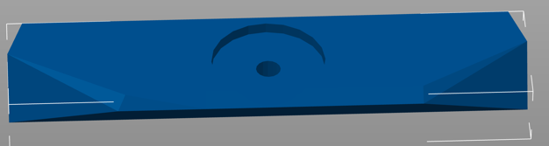

1\*J3: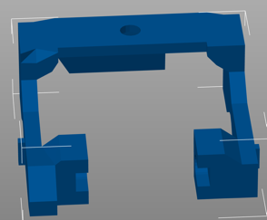

2\*J6: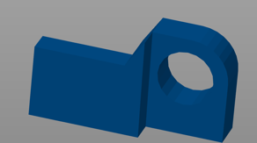

1\*J7: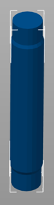 M1: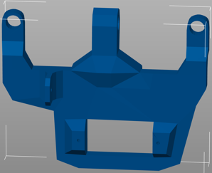 1\*M2: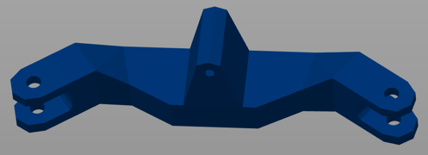

1\*M3: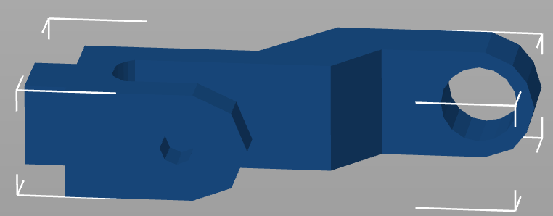 2\*M4: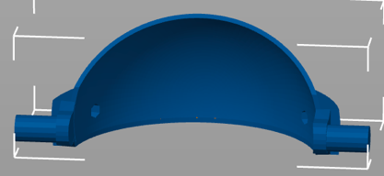

2\*M5: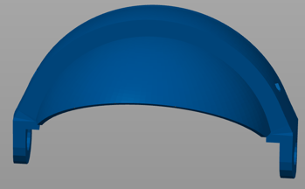 1\*S1: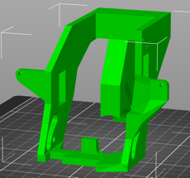 1\*S2: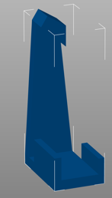

1\*S3: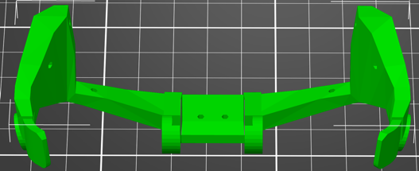 1\*S4: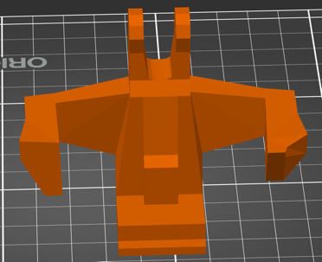

1\*T1: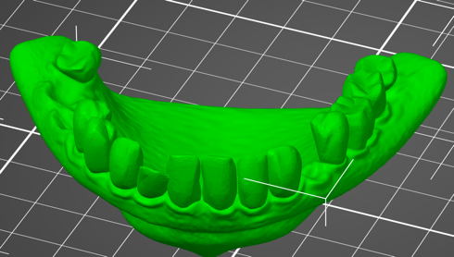 1\*T2: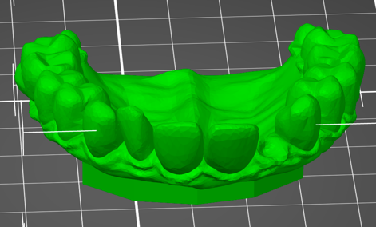

2\*E: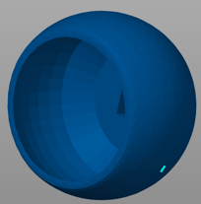 1\*RC: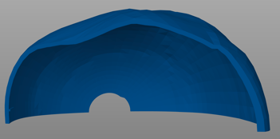 1\*RL: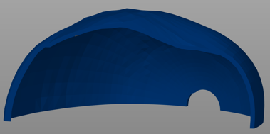

Tutorial:

1. Connect the M2 to both M3 using two m3 screws connector ( you may use hot glue to position the screw connector inside the M2 so there will be minimum loose)

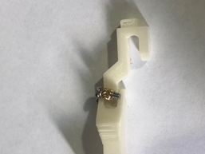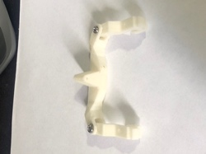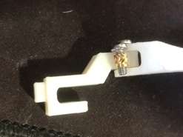

1. Connect M2 and M3 to the M1 using the same screw connector,

* the hook on the M1 supposed to be directed down.
* Use the same screw connector and two m3 screws

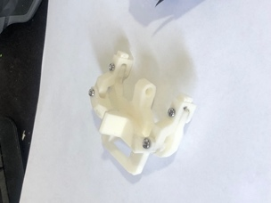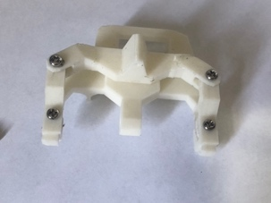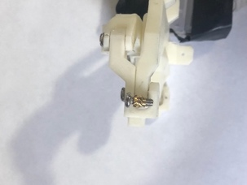

1. Using two m3 screws and 2 screws connectors connect M1 to S4, screws head should be in the outer side of S4

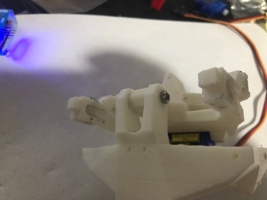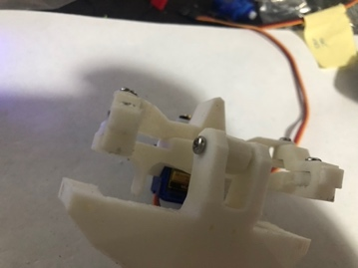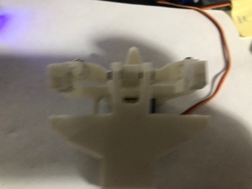…………………….

1. Connect one mini servo to the M1, servo hand should be assemble from the left size, plug one pushed stoper to the servo and connect one hook to it , the hook should be inserted into the small hole in the M1 part

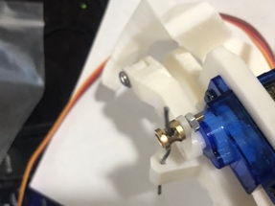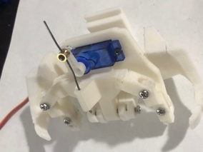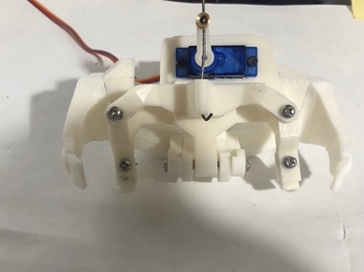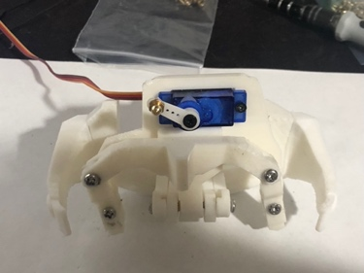

1. Take both J6 parts and glue them to the side of J3, after that plug both J5 parts to the H6 hole

* Flat part of J6 should be directed down.
* Before glue J6 parts make sure they move a bit loose in the S1 rials, if they don’t move loose, gently sand the S1 rails.

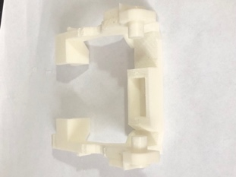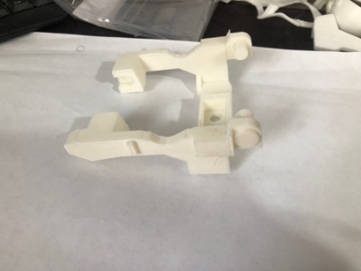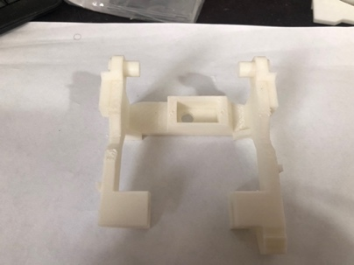

1. Screw one mini servo to the J3.

* The servo should be metal and a bit stronger because it need to lift and move the jaw part of the skull.

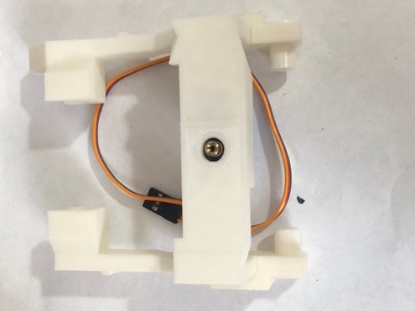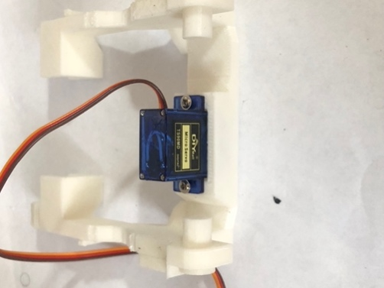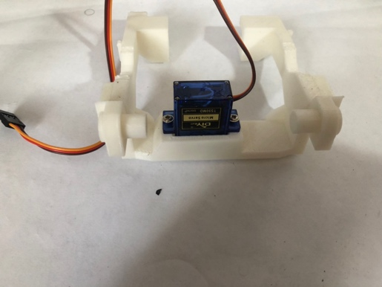

1. Take F3 and F4 and glue them together to T2

* Make sure you leave enough place between F3 and F4 to place J1

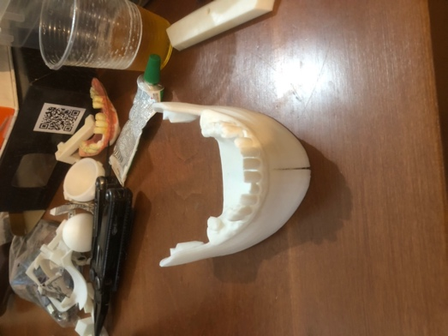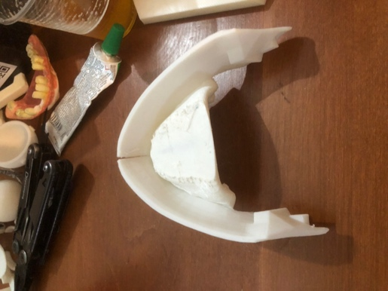

1. After the last part dry, connect glue J1 between F3 and F4,

* Servo wheel adapter should be position up direction, while its open side should be pointed opposite direction then the teeth

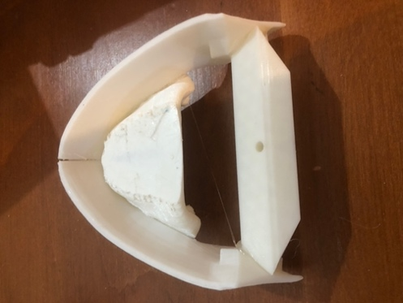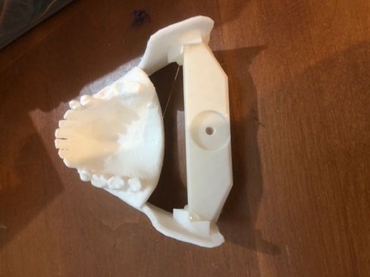

1. Use two m2 screws to connect F1 to the eye mech to build in the previous episodes, follow the same with F2

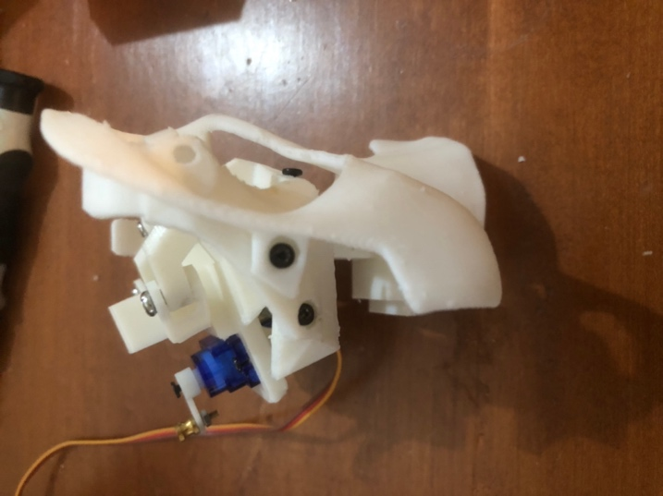 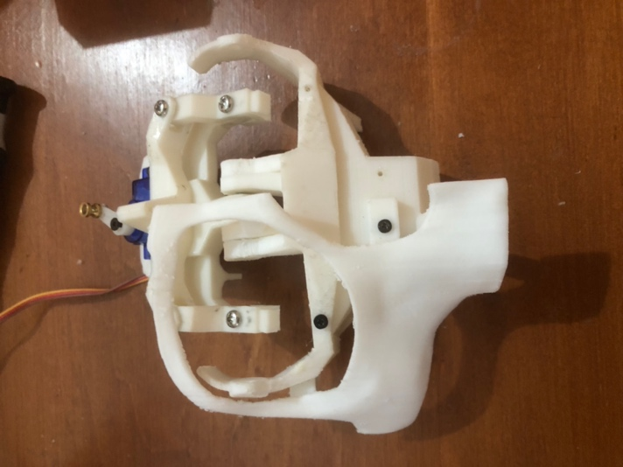

1. After co nnecting F1 and F2 to the face, glue T2 to it.

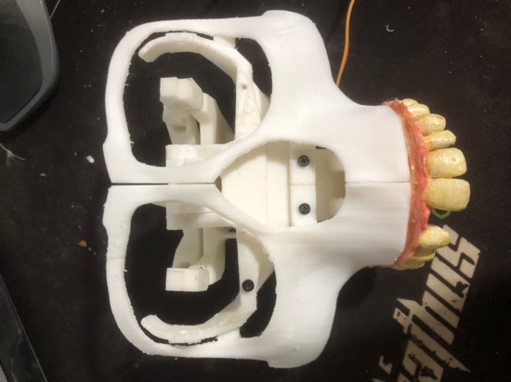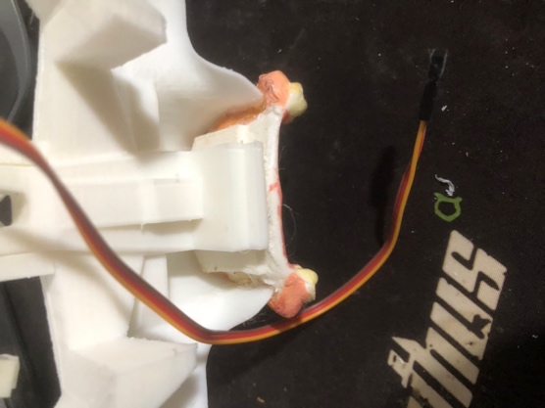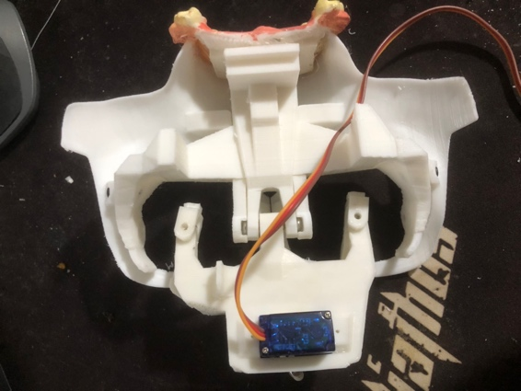

1. Use one hook connector to connect the xEyesServo to M2 part,

* check for smote movement
* check for the servo min max and base degrees
* save them as XeyesMin, XeyesMax, xEyesBase for future instructions

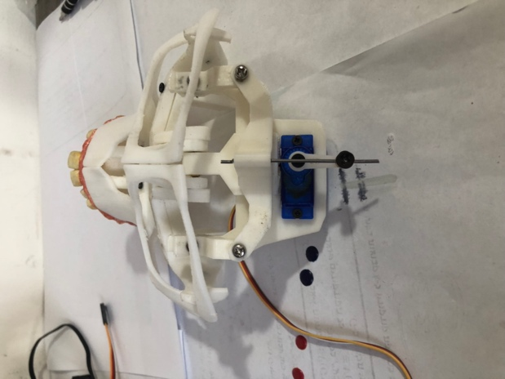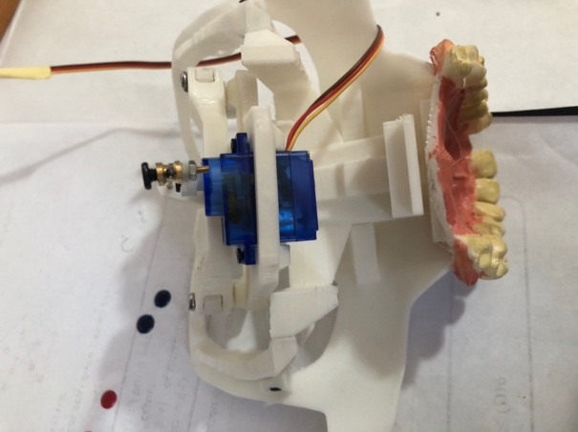

1. Take the assembled J3 from stage 6 and connect it to S1 carefully using J7

* Before glue the parts make sure you got a full and easy movement, otherwise the servo will not be able to move it smoothly, if needed polish S1 to getter a smoother movement.

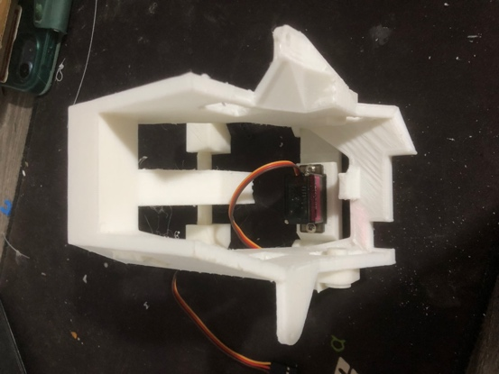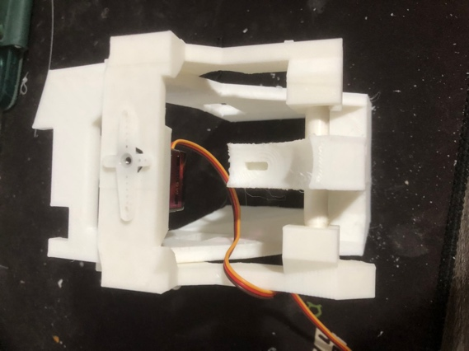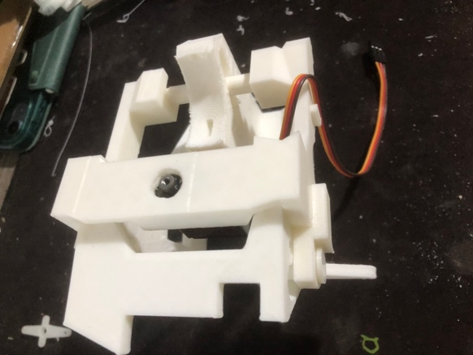

1. Connect two servos to the sides of S1.

* servos should be direction up

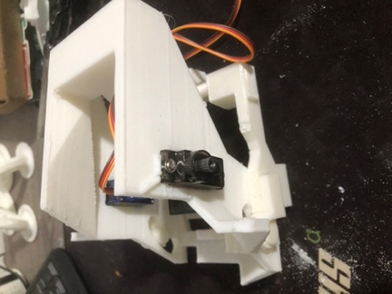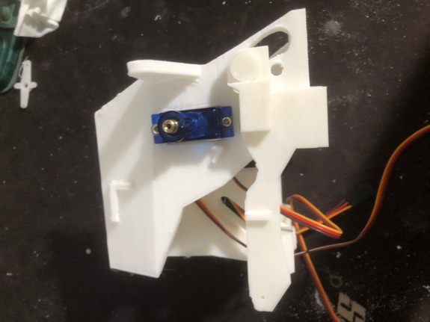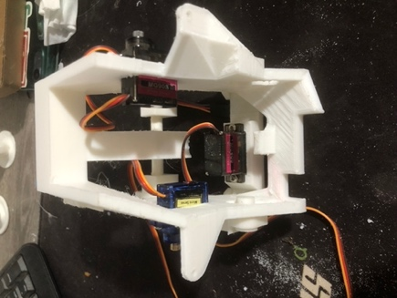

1. Take S1 and connect it to J1 using 1 mini servo

* This is the one of the important part in the assembly,
* drill one servo hand or weel to J1 , the screw hight should not be higher then the J1 circle hole other wise the jaw will not be closed smoothly on the final assembly
* use strong servo and connet it with a screw from the hole at J1 directly to the servo hole in S1.
* You better make sure evrything is works good now instead of taking all apart later
* After done it right check the servos min max and base degree as JawMin ,JawMax ,JawBase for future instuctions .

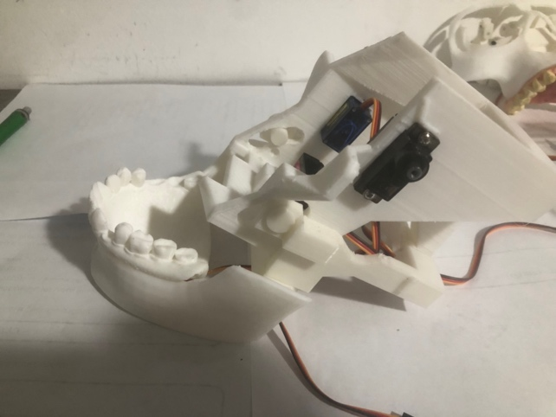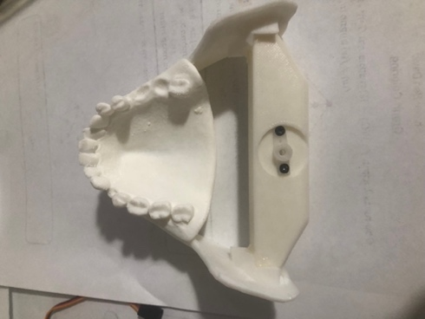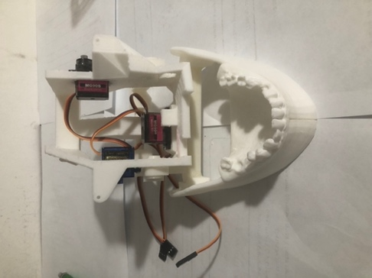

1. Sling N1 into B1 hole, check for smooth movement , j1 should be place under B1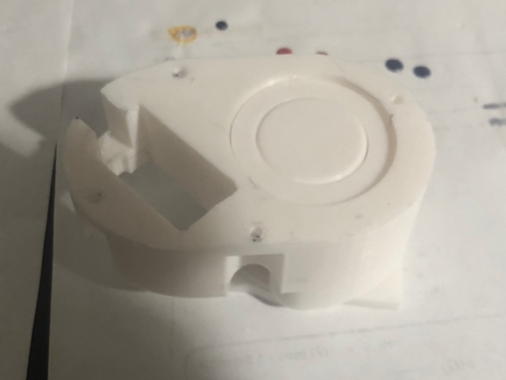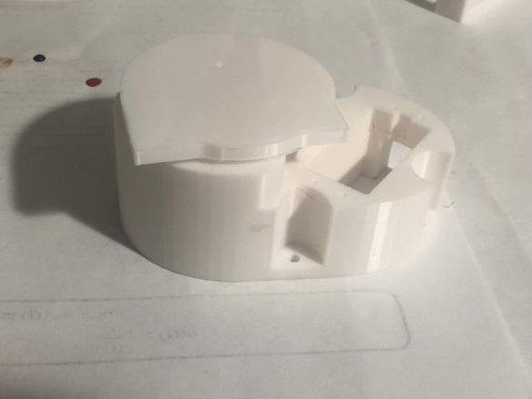
2. Connect with a hook one servo from B1 to N1

* You should use hook connector on servo and on the N1
* Check for servo movement before continue, after the next step recalibrate the servo position will be hard and you will have to unglue the parts
* After screwing the servo check is min and max angle and save them aside for future instructions

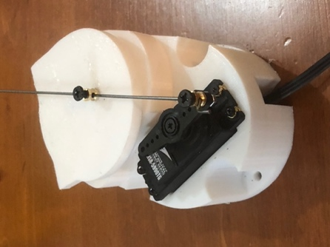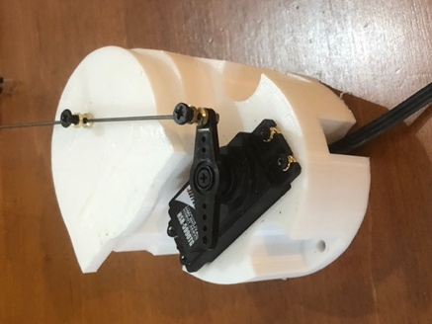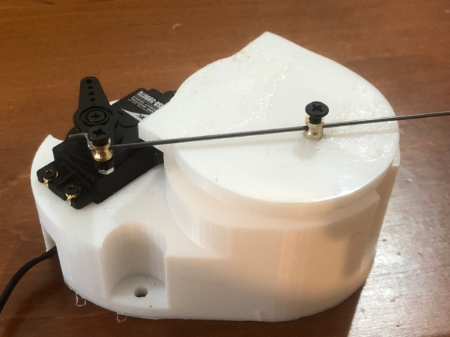

1. Glue N1 to N3

* Bottom servo should be lined with N1 flat size

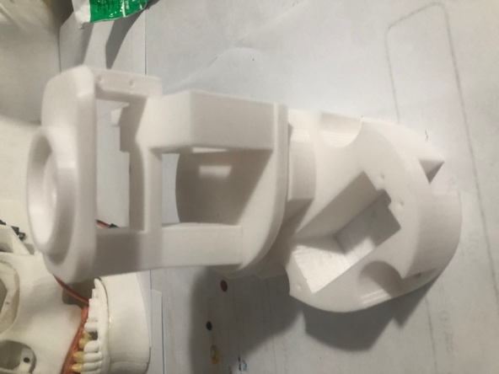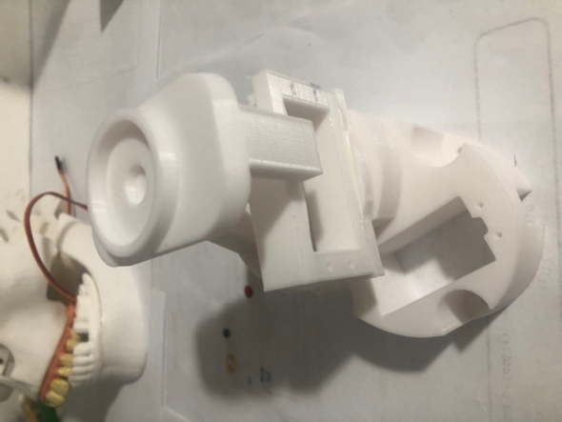

1. Glue N2 to N3

* Make sure the glue dosent leaked to the hole other wise it will make you hard time to connect the skull head to the neck

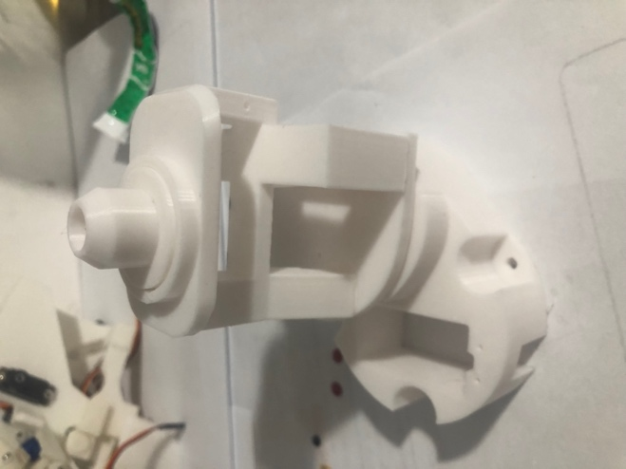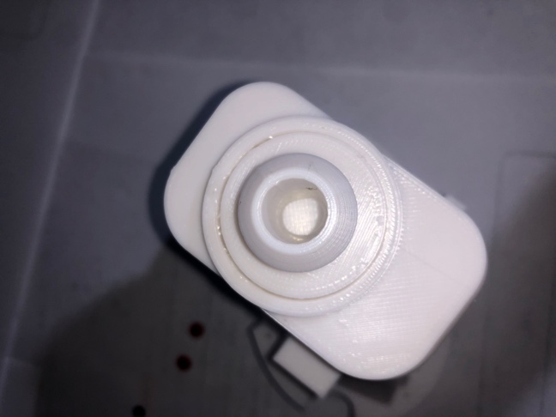

1. Glue N5 to the side of N3

